**Greggs Products**

1. As a Greggs Fanatic I can see the list of product items by using the ‘Get’ /Product option, no authentication is needed.

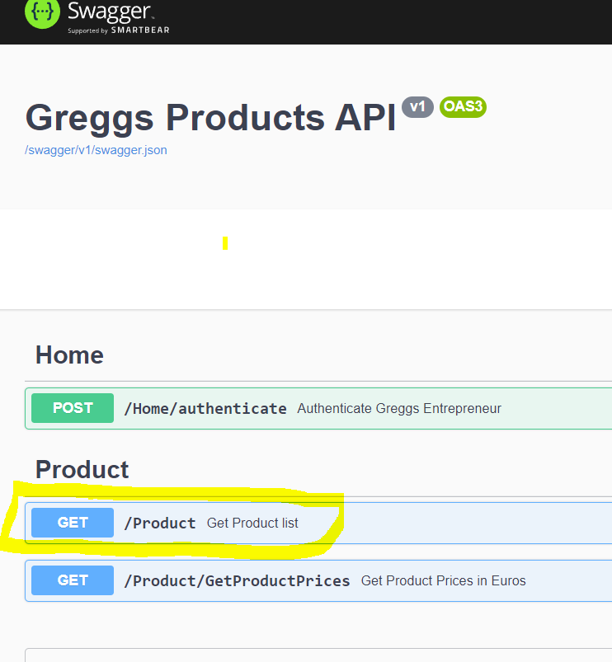

1. As a Greggs Entrepreneur in order to see a listt of products returned with the price Euros

I need to first use the ‘Post’ /Home/Authenticate to gain a tocken by logging in.

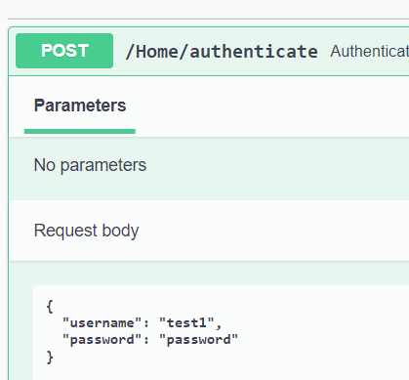

Hopefully you will get a token, copy yhen paste the token into the Authorise section

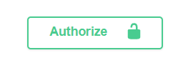

Then select the ‘Get’ /Product/GetProductPrices

